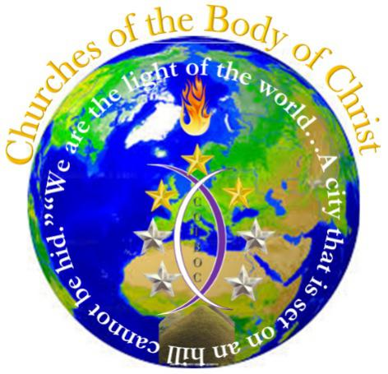

WWW.COTBOC.org
Mission Statement
“Perfecting the body in the unity of the faith”

It is the mission of COTBOC to serve as the headquarters for a network of like-minded ministries. The like-minded nature of these ministries is in the foundational belief that “…Man shall not live by bread alone, but by every word that proceedeth out of the mouth of God.” Mt. 4:4 KJV and “All scripture is given by inspiration of God, and is profitable for doctrine, for reproof, for correction, for instruction in righteousness.” 2 Ti. 3:16 KJV. In a likewise manner we also understand that in this belief it does not just call for doing so by interpretation (Our natural thought of what we think God is saying), but rather in revelation (That which the Spirit actually is saying causing us to be in a true state of fruitfulness). It is furthermore the mission of this organization to cover ministries focused on perfecting the body in the unity of the faith, while fostering an atmosphere that will provide continuous training that will ensure it remains the ongoing focus of those covered ministries. It is also mission focused on raising a generation of leaders that will not be heady, high-minded, greedy, and unholy which damage the people of God causing them to be ineffective in the earth; but that will understand the role of their calling and operate in excellence therein. Also, leaders that are not threatened by the call on the lives of God’s people, but that will nurture and propel them in to their God given purpose. Lastly, leaders that will not waste valuable time with petty arguments of who is greater, not called, or ineligible for service as the call to ministry is never bound by bond/free, male/female, race/nationality; but would rather be led by God that we may co-labor with whoever He chooses that His purpose may be served, not our agenda.
Finally, it is the mission of this organization to be a beacon of light in the world, a comfort to the faithful, and reminder to those that may have lost their way that He is God and God alone and that He can only be reflected through us as we believe united in the faith!

Amen

