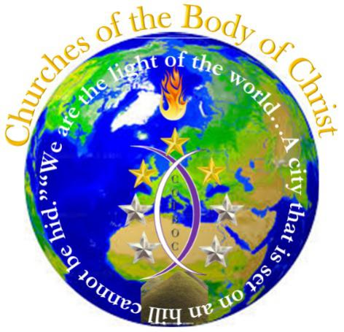

WWW.COTBOC.org
Recipient Acknowledgement form
“Perfecting the body in the unity of the faith”
P.O. Box 468
Frederick, MD 21705
(240)347-1835

I, _________NAME ON FILE_________ hereby acknowledge that I have received a copy of; Welcome & Initial Instruction Letter, COTBOC Mission Statement, COTBOC Introduction Statement, Ordainment/Consecration Certificate, and Wallet Credential Card. I furthermore acknowledge that I have read and understand the documentation received, and that these documents may be revised or updated as necessary. I also agree to adhere to and always be in compliance with the terms of these statements.
Print First & Last name
Please initial in the space provided to the following:
I agree that I will not leave the covering of COTBOC without formal written notice. ___X____
I will not act in any way the will bring negative reflection upon COTBOC or its affiliate organizations. __X_____
I will seek the council of the Overseer of COTBOC should I ever be found in fault that may bring negative impact in the ministry I oversee. __X_____
I agree to attend the twice monthly leadership trainings and will give forenotice should I not be able to attend that my absence will be excused. __X_____
Keep for your records, this form is validated and binding by the electronic submission of your covering agreement otherwise void.
_VALID WITH ELECTRONIC SUBMISSION_______ SAME AS TRANSMIT DATE__
Signature Date

