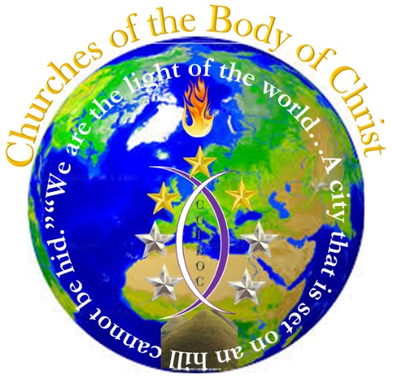

WWW.COTBOC.org
Introduction Statement
“Perfecting the body in the unity of the faith”

COTBOC is an organization specifically created for the covering of ministries. Its primary purpose is to create the ability to share real property throughout the covered ministries i.e. buildings, vehicles, equipment, etc. Furthermore, COTBOC is a denominational tag that associates all ministries that fellowship under its covering and can suffix a ministry name if so desired by placing C.O.T.B.O.C. (Churches of the Body of Christ) at the end of the ministry name. Although COTBOC is a denomination, it functions differently from the traditional sense of the term in that it is a covering for non-denominational churches which even in its affiliation with the denomination causes them to remain non-denominational in structure, as it does not set the tone for nor establish belief for ministries it covers, but rather serves as a support system and affiliation for those ministries. With that however being said, the churches that it does cover must line up with sound doctrine in accordance with the word of God to be covered by it, which again is where traditional denominations differ as they limit sound doctrine through beliefs derived by interpretation.
In COTBOC the primary role of jurisdictional oversite is done by the Office of the Apostle; however, there are times where Bishops may be called upon to sit in such a role and therefore will be promoted to a presiding capacity as opposed to just local overseeing capacity. When Bishops are promoted to presiding level they will oversee those at the Pastoral level (pastors), as bishops will be overseen by apostles (biblically the juridical overseer) Act 1:20. Apostles and Bishops alike within COTBOC must stand ready to be tasked at a moments notice and ready to serve the work of the ministry according to the needs within the organization.
There are two types of ministries COTBOC covers:
- In-House
In-house ministries are those that are seeded (created) directly by COTBOC. In this instance COTBOC is directly responsible for establishing, training and ordaining the leadership, and physical placement of the ministry. It’s also essentially involved with the setting of doctrine, monitoring the financials, deciding of successors, ability to sit on the board of directors, and guidance related to day to day operations. This does not interfere however with the pastor being able to perform their duties and is left to do such. Likewise, In-house ministries are subject to a covering fee which when collected is deposited in an escrow acting as a savings account to assist in needs that may arise outside the scope of general operations. The pastor and first lady of in-house ministries are also required to become members of COTBOC’s associate organizations HOO (Holy Order of Overseer’s) for the pastor and LOO (Ladies One with Overseer’s) for the first lady, as these organizations provide direct support to their respective offices and further maintain the health of them in the ministry.
- Existing
Existing ministries are those that have been founded by others that request covering by COTBOC. These ministries are only subject to providing COTBOC with establishing documents (to determine if covering is possible). Should COTBOC have questions about issues of doctrine of an existing ministry consultation will be made to ensure that all deficiencies are understood and can be eliminated that the ministry is ensured to be operating upon sound doctrine prior to taking on cover responsibility. Covering fees and the sharing of financial information is strictly optional for existing ministries, but if elected to do so are regarded in the same sense of in-house ministries. Primarily for existing ministries COTBOC merely serves as a place of advisement, resource, and support should it be necessary. The HOO & LOO membership for the pastor and first lady of existing ministries is optional; however, is it strongly encouraged!
The pastors of all covered ministries regardless of status (In-house/existing) are required to attend training sessions two times monthly by phone/video conference. This insures that all ministries in fellowship are of one mind and in keeping of sound doctrine, these sessions are held by the overseer of COTBOC.
The use of COTBOC property:
All covered ministries can utilize property that is owned by COTBOC, whether it be utilizing a building (if applicable), use of vehicles, computers, sound equipment, etc. However, when in use of this equipment it must be maintained with high standard. Any property that can be utilized within a building setting i.e. computers, microphones, etc. will bear a tag “Property of COTBOC” and will be subject to inspection and/or inventory. The “Property of COTBOC” tag is not to be removed and must be communicated to COTBOC should the tag become damaged in any way or missing, so it can be replaced as a record is maintained at COTBOC the location of all property utilized by covered ministries. Should and existing ministry no longer wish to exist under the covering of COTBOC all property belonging to COTBOC must be returned in a prompt fashion. Should the covered ministry have dire need of the equipment in question COTBOC may consider selling the property to the ministry at a fair rate considering depreciation. Should property be damaged while in the possession of the ministry it should be made known to COTBOC immediately so that it can be determined if the property may be under warranty of some kind and can be easily replaced.
Convocation:
COTBOC will have an annual convocation it is desired that all churches in fellowship attend, as this will be the time that all fellowshipping ministries will be able to communicate, network, love on each other just as any family would in such fashion of reunion. However, if a ministry cannot be physically represented, if it be all possible that ministry can send a love gift to help to the efforts of the convocational expenses.

Logo Explanation:
Globe referencing it as a worldwide organization

Connected lines with acronym COTBOC in the middle indicate ministries in fellowship through the organization.
The seven stars are the (stars of unity) the three gold represent the Trinity the four silver; man, woman (marriage), five-fold ministry, and the church. As this is the alignment necessary for perfect unity within the household of faith.

The connected lines (ministries) with the acronym COTBOC in the middle create a candlestick that sits on a hill with a flame atop, all in the middle of the globe indicating our collective responsibility to be the light shining throughout the world. (encircled by the scripture in statement)

